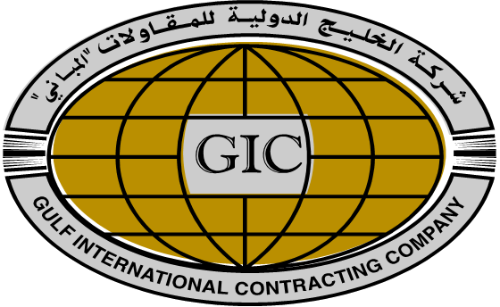
KASHIF ALI KHAN
Mobile: +965 99404636 Telephone: +965 25646007 E-Mail: k.khan_gulf@yahoo.com

PROFESSIONAL SYNOPSIS
- Highly talented Middle Management Operations/ Support management professional with over 15 years of high quality experience in Administration, Purchasing, Logistics & Support Management, Being in Kuwait Working with Retail, F&B, Catering & as well as Construction fields in reputed Companies.
- Strong ability to master a situation quickly; highly knowledgeable in various aspects of the Procurement field.
- Adept at handling day to day activities in co-ordination with internal / external departments for smooth business operations. A keen communicator with the ability to relate to people across all hierarchical levels in the organisation.

PERSONAL KEY SKILLS

- Communications Skills
- Analytical/Research Skills
- Computer/Technical Literacy
- Flexibility/Adaptability/Managing Multiple Priorities
- Interpersonal Abilities
- Leadership/Management Skills
- Multicultural Sensitivity/Awareness
- Planning/Organizing
- Problem-Solving/Reasoning/Creativity
- Teamwork

CAREER HIGHLIGHTS

Since May’2009 - Present with Gulf International Contracting Co, (Al – Sharq Kuwait) as Procurement Supervisor

COMPANY PROFILE:
- Gulf International Contracting Company (GIC) is a Kuwait registered Company, established in 1992.
- GIC has successfully completed over KD 60.6 Millions of projects in both Government and Private Sectors.
- The Diversity of GIC is evident by the success of GIC Catering, has been the dominant Catering Media for Ministry Zones MOH/MOI/KNPC in the region.
- GIC is also Kuwaiti Agent for various Foreign Companies such as Red Sea Housing Services of Saudi Arabia, SESCO- Saudi Electrical Supply Company, Thrust Boring Construction Company Ltd.

Accountabilities:

- Involves all Purchasing and administrative work. Self-correspondence, and routine office works and to provide necessary assistance to my superiors.
- To supervise all the purchases from Invent System & Delivery status with regular Vendors.
- Updating records of daily Purchases & reporting to Finance Department.
- Handling Locations like Ministry of Health Sabah Chest Hospital, Maternity Hospital, Nurses Hostel, K.N.P.C Ahmadi & as well as M.O.I Project like Central Jail & All Police Academies.
- To supervise daily basis orders like (Fresh vegetables & fruits, Eggs, Fresh Meats, Milk, Breads, Fishes & Fresh Chicken).
- To participant with Tenders & Price Analyses from Kuwait local Market Prices & prepare Costing sheet for Tenders.

Since April’2007 – March’2009 with Ali Abdul Wahab Sons & Co, (Al – Sulaibiya Kuwait) as Warehouse / Logistic Supervisor

COMPANY PROFILE:
- Ali Abdul Wahab Co. brought Kuwait closer to the world’s best and most demanded personal, beauty, home, family, and health products since the 1950s.
- Ali Abdul Wahab Co. been one of the largest distributors of Procter and Gamble products since then, and have continued to add world-class consumer products to portfolio.
- Ali Abdul Wahab Co. Over 800 P&G products to the Kuwaiti market on a daily basis. Our P&G portfolio includes Pampers, Tide, Ariel, Always, Pantene, and Wella to name a few.
- Ali Abdul Wahab Co. Partnership with P&G started in 1950, beginning with spot trading of one of its key brands, Tide.
Accountabilities:

- Involves all logistics activities as well as manage all Shipments International and from G.C.C. countries.
- Arrange the receiving goods according to exact location.
- Preparing the Shortages, Excess or any damage report after unloading the goods.
- Shipped the goods for all over in Kuwait areas as well as All Coops, Pharmacies & etc.
- Manage the physically stock of every three months & reporting to Supply Chain Department.

February’2004 – March’2007 with Ace Hardware / Al-Hasawi Group (Al – Rai Kuwait) as
Procurement Supervisor Local / Overseas

COMPANY PROFILE:
- Ace Hardware, an America household name in hardware retailing has been in Kuwait since 1991.
- Store with a wide range of items from niche departments of construction materials, home improvement items, maintenance products and DIY projects.
- From its humble beginning to what it is now, Ace hardware has catered to the demand of customers who come to the store for quality products, affordable prices and a customer service far better than any hardware store in Kuwait.

Accountabilities:

- To make the purchase orders according to requirements from Location Managers & arrange delivery on time.
- To follow up the inquiries from US Army & as well as Local customers.
- To fixed the retail prices in System according to Retail Manager.
- To search in the market new vendors because of good quality & Prices.

EDUCATION
- B.COM (Bachelor of Commerce) University of Karachi (Grade - B), Karachi, University, Pak – (1998 – 2000)
- I.COM (Intermediate of Commerce) Superior College (Grade - C), Karachi, Pak – (1995 – 1996)

IT SKILLS:
- MS Office (Word, Excel, PowerPoint)
- Omega System
- Jd Edwards
- Advac System
- Sybase Invent System

PERSONAL DOSSIER
Date of Birth : November, 05th 1976
Nationality : Pakistani
Marital Status : Married
Languages known : English, Arabic & Urdu
Visa Status : Article 18 (Transferable)
Driving License : Valid Kuwait
Address : Yousef Al-Bader Street Salmiya, Kuwait
Reference : Available as per request


